GENERATION AND ANALYSIS OF FREQUENCY MODULATED (FM) AND PHASE MODULATED (PM) SIGNALS USING MATLAB
Analog and Digital Communication — MATLAB Experiment
Date of Experiment | 12/10/2026
Performed By | Lokesh A
Register Number | 192512293
1. Aim
To generate and analyze Frequency Modulated (FM) and Phase Modulated (PM) signals using MATLAB, and observe the message signal, carrier signal, FM waveform and PM waveform.
2. MATLAB Program
clc;
clear;
close all;
Am = 1;
Ac = 1;
fm = 5;
fc = 50;
beta = 5;
kp = 5;
fs = 1000;
t = 0:1/fs:1;
m = Am*cos(2*pi*fm*t); % Message signal
c = Ac*cos(2*pi*fc*t); % Carrier signal
fm_sig = Ac*cos(2*pi*fc*t + beta*sin(2*pi*fm*t)); % FM
pm_sig = Ac*cos(2*pi*fc*t + kp*m); % PM
Df = beta*fm; % Frequency deviation
fprintf('Frequency Deviation = %d Hz\n', Df);
fprintf('FM Modulation Index = %d\n', beta);
subplot(4,1,1), plot(t,m), title('Message Signal')
subplot(4,1,2), plot(t,c), title('Carrier Signal')
subplot(4,1,3), plot(t,fm_sig), title('FM Signal')
subplot(4,1,4), plot(t,pm_sig), title('PM Signal')
3. Output
The MATLAB simulation displays four waveforms: the message signal, carrier signal, frequency-modulated signal and phase-modulated signal. The Command Window also displays the calculated frequency deviation and FM modulation index.
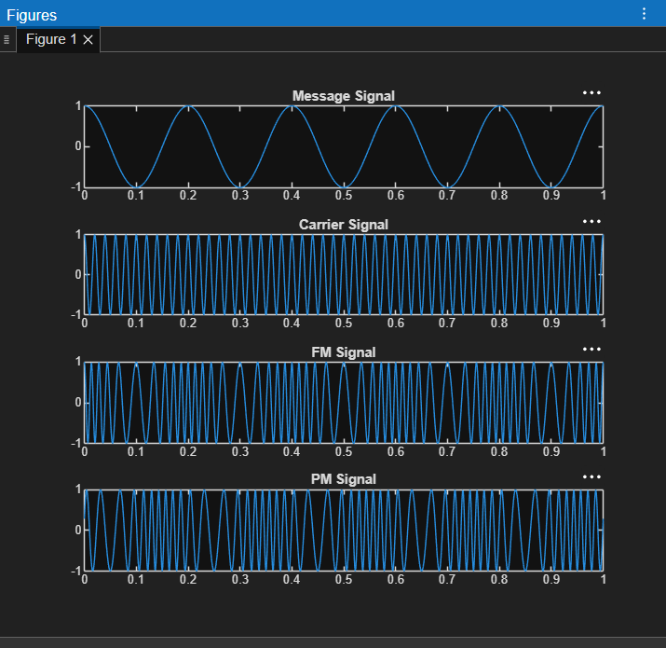
Figure 1. MATLAB plots of the message, carrier, FM and PM signals.
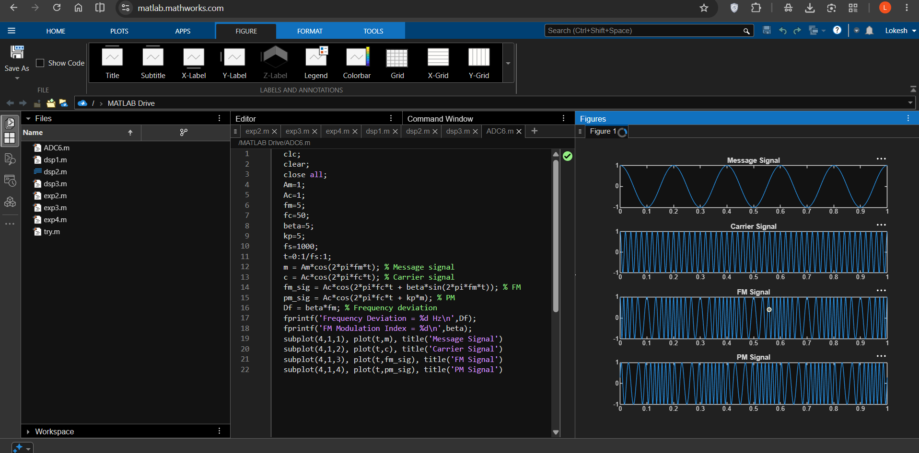
Figure 2. MATLAB program and graphical output.
4. Applications
- FM radio broadcasting for high-quality audio transmission.
- Wireless communication systems that use frequency variation to represent information.
- Telemetry and communication links where frequency modulation conveys measurement or control information.
- Phase modulation as a foundation for digital phase-based schemes such as PSK.
5. Alignment with Analog and Digital Communication
This experiment demonstrates angle modulation, specifically frequency modulation and phase modulation. It shows how the message signal changes the instantaneous frequency or phase of a carrier and how the resulting waveforms can be observed in MATLAB.
ADC Concept | MATLAB Implementation | Observed Output
Message signal | 5 Hz cosine signal | Message Signal plot
Carrier signal | 50 Hz cosine signal | Carrier Signal plot
Frequency modulation | Phase term includes beta*sin(2*pi*fm*t) | FM Signal plot
Phase modulation | Phase term includes kp*m | PM Signal plot
Frequency deviation | Df = beta*fm | 25 Hz
FM modulation index | beta = 5 | 5
6. Justification
- The message and carrier plots establish the two signals involved in angle modulation.
- The FM waveform demonstrates how instantaneous frequency varies with the message signal.
- The PM waveform demonstrates how instantaneous phase varies with the message signal.
- The frequency-deviation calculation links the MATLAB model to a key FM parameter.
- Displaying FM and PM together makes it easier to compare two forms of angle modulation.
7. Conclusion
Frequency Modulation and Phase Modulation signals were generated and plotted using MATLAB. The simulation displayed the message and carrier signals alongside the FM and PM waveforms. The calculated frequency deviation and modulation index provided numerical measures of the FM setup, while the plots illustrated the behavior of both angle-modulation methods.
Performed by
Lokesh A (192512293)

